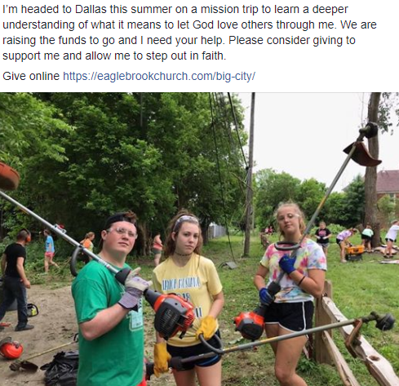

Other things to post about:
- Training pics
- Faith story
- Asking for job/work opportunities
- Babysitting/service projects to earn money
- Progress updates on your fundraising
- How you are feeling about going the closer it comes
- Past experiences from yourself or others on your team
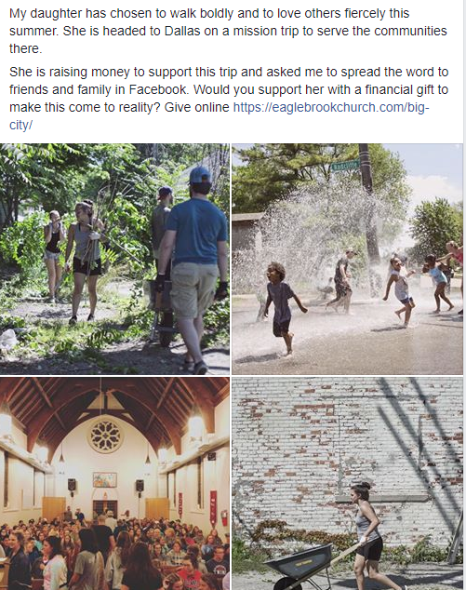

Other things to post as a parent:
- Asking people to repost and spread the word
- Looking for fundraising opportunities for the team
- Babysitting/service projects to earn money
- Progress updates on their fundraising
- Past experiences from your student or others on the team

