How to See Who’s on the Group Roster

- Go to your group’s page in MyEBC
- To see a list of participants, either:
  - Click on the Participants tab (good for a smaller group)
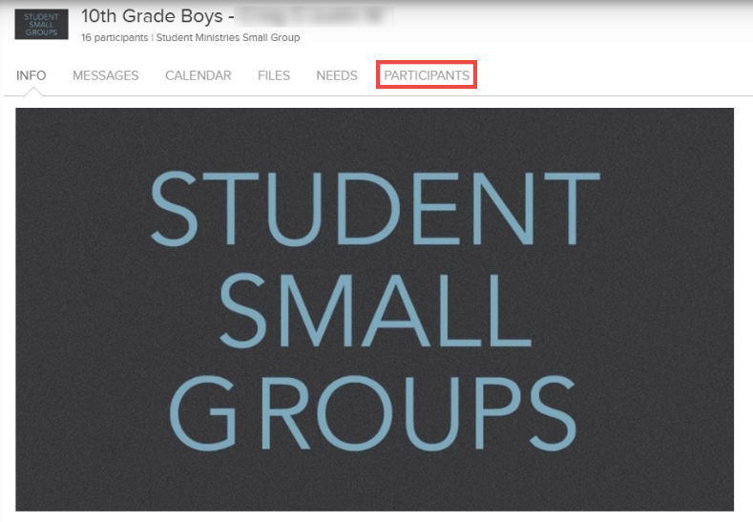
  - Click on the Reports icon and select Export Individuals (good for a larger group)
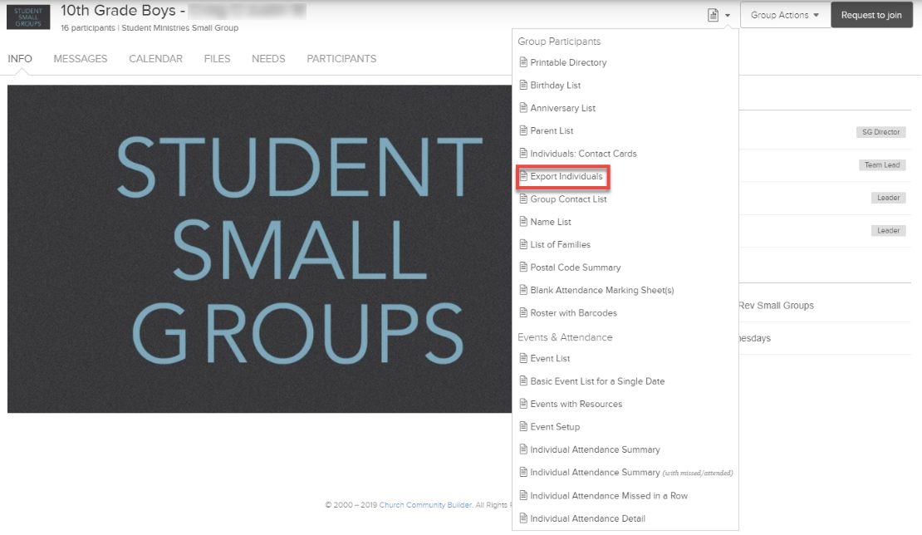

How to Run an Attendance Report

- Go to your group’s page
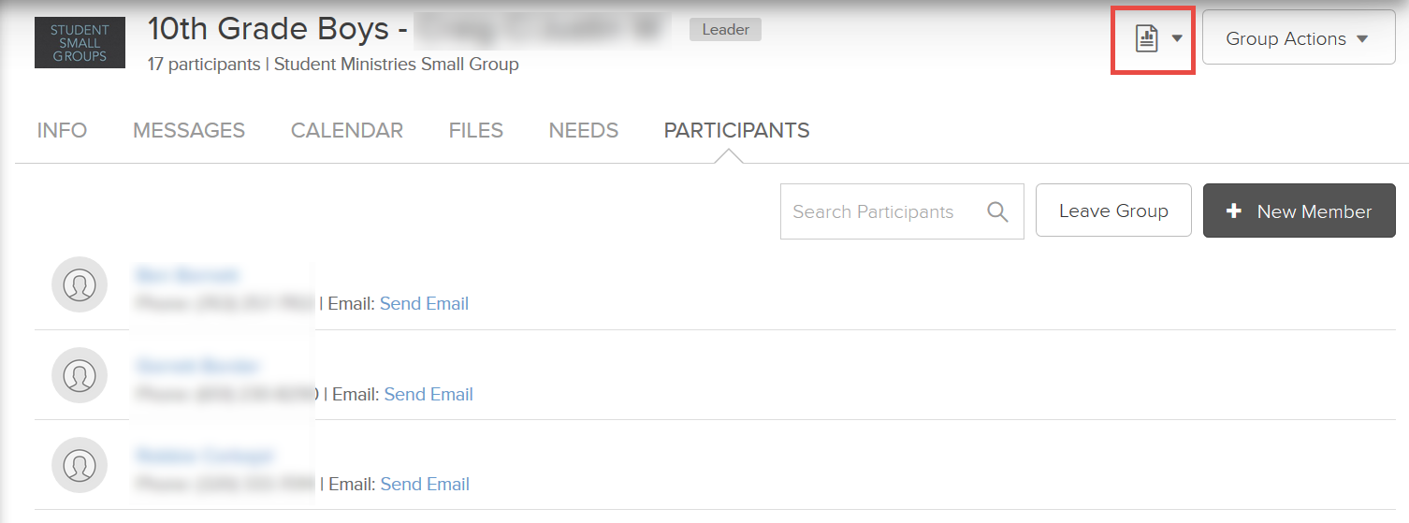
- Click on the Reports icon

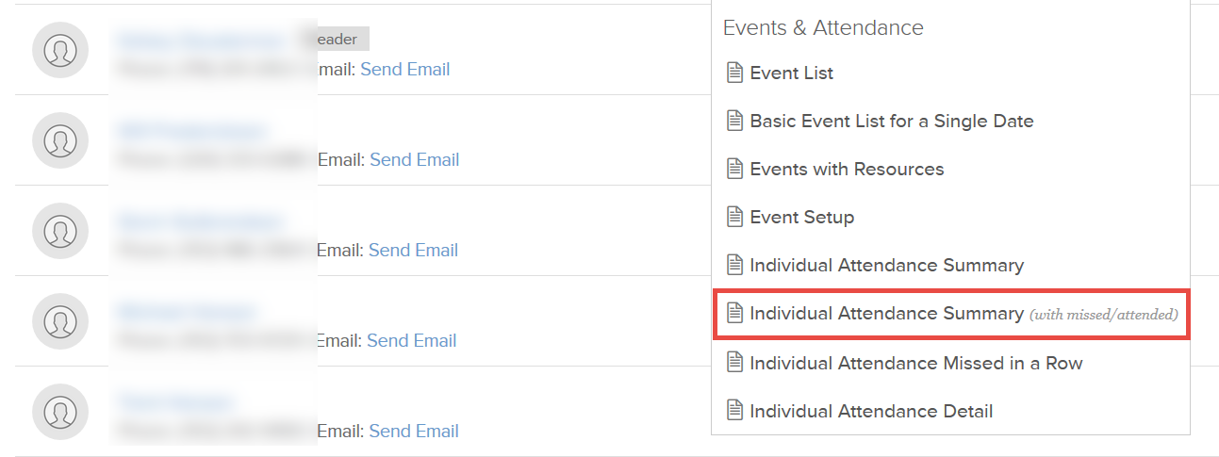
- Click Individual Attendance Summary (with missed/attended)

- In the box that pops up:
  - Enter the dates of the last school year
  - Select Once per week (Saturday-Friday)
  - To see who has never attended the group, select Attended, Less Than, 1 Time (these are the people you will want to remove from your group)
  - To get a breakdown of each member’s attendance, select Attended, Greater Than or Equal To, 1 Time (will not show people who have never attended)
  - Choose preferred output method
  - Click Run Report

How to Remove or Add Participants

- Remove:
  - Click Group Actions in the top right corner of your group’s page
  - Click Edit Participant List
  - Check the boxes next to the people you’d like removed
  - In the dropdown menu, select Remove from group (see below left)
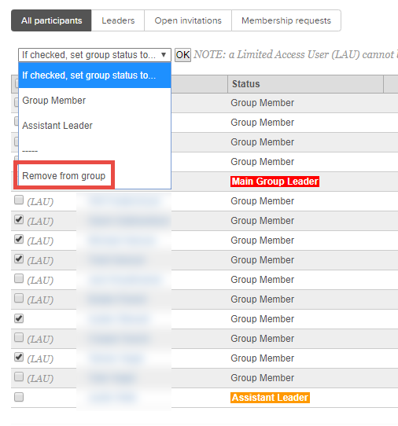
  - Click OK

- Add:
  - Click the Participants tab in your group’s page
  - Click +New Member
  - Click People by Name
  - Type in the names of the people you’d like to add (make sure to keep Add Directly selected)
  - Click Add Now

